Paper Review System

UI Mockups or Screens

‘LOGIN’ UI webpage screen
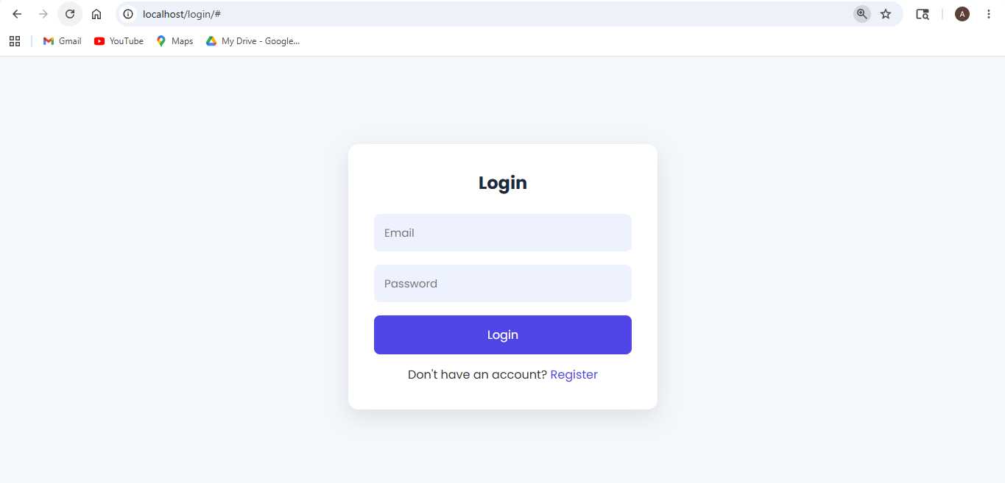

‘REGISTER’ UI webpage screen

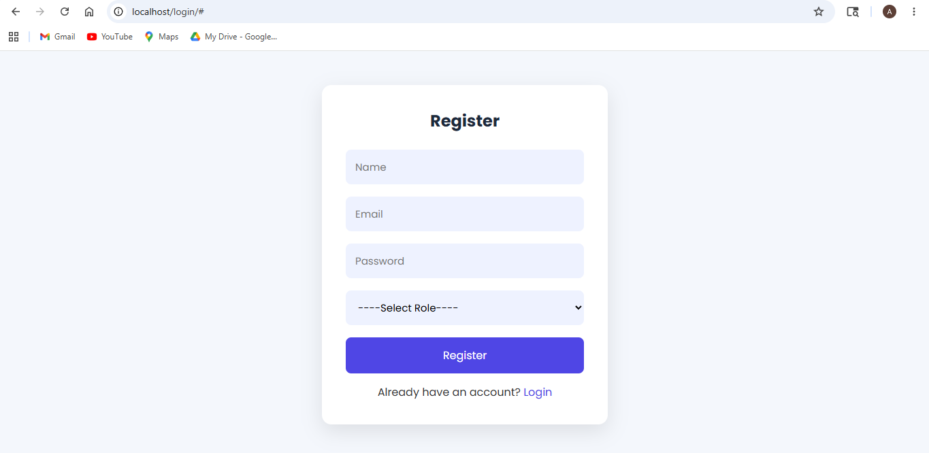

With select Role of all 4 users (Author, Reviewer, Organizer and Admin)
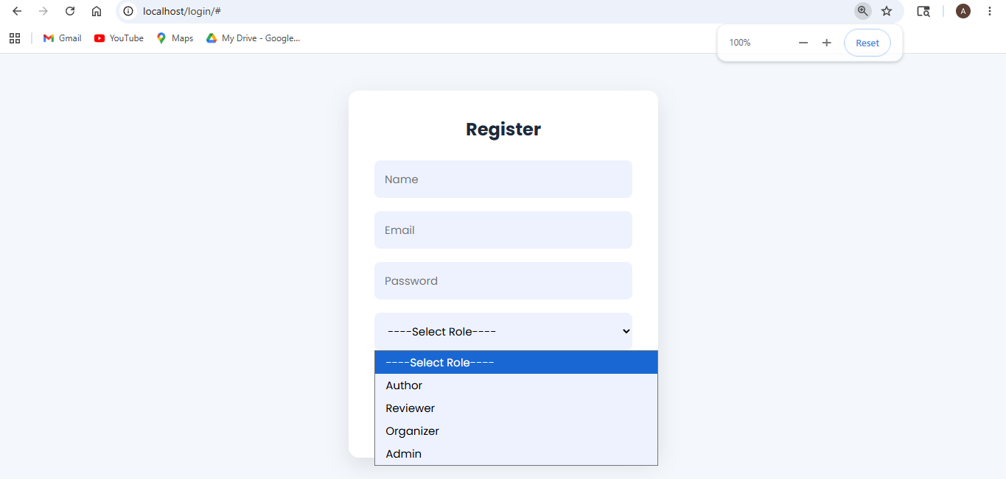

Author Dashboard UI webpage
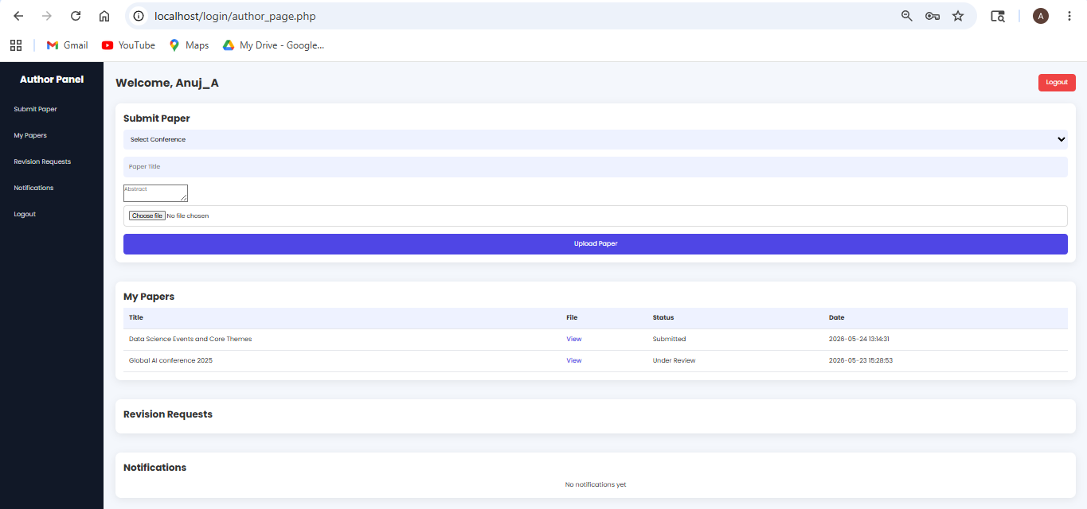

Organizer Dashboard UI webpage
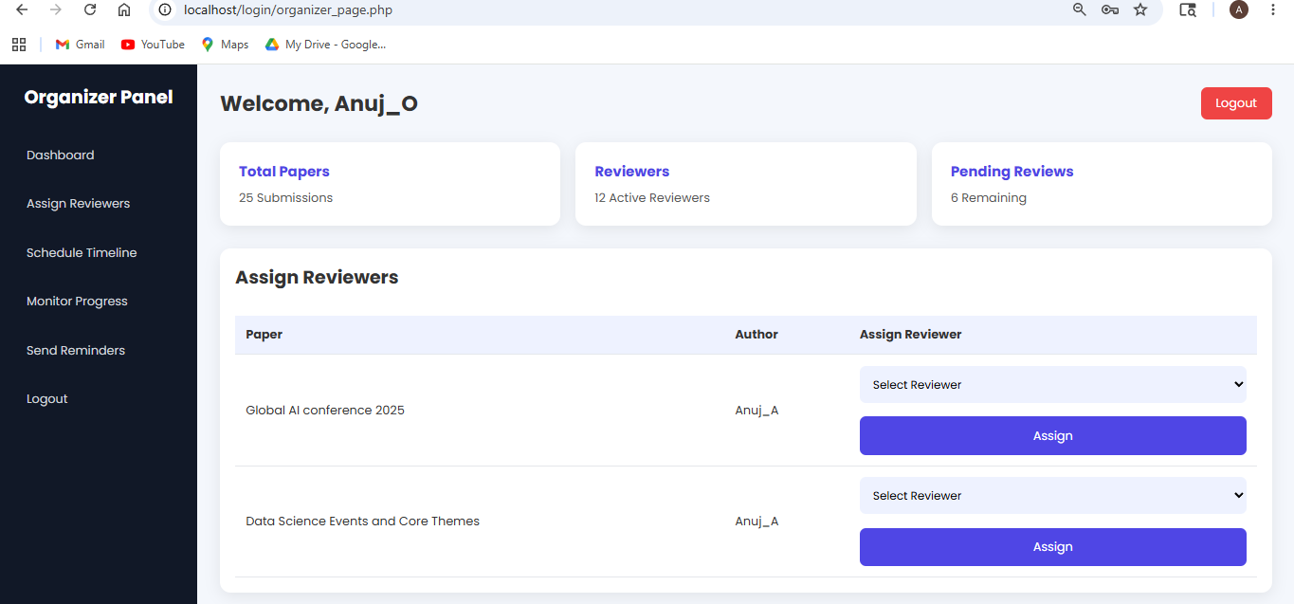

Reviewer Dashboard UI webpage
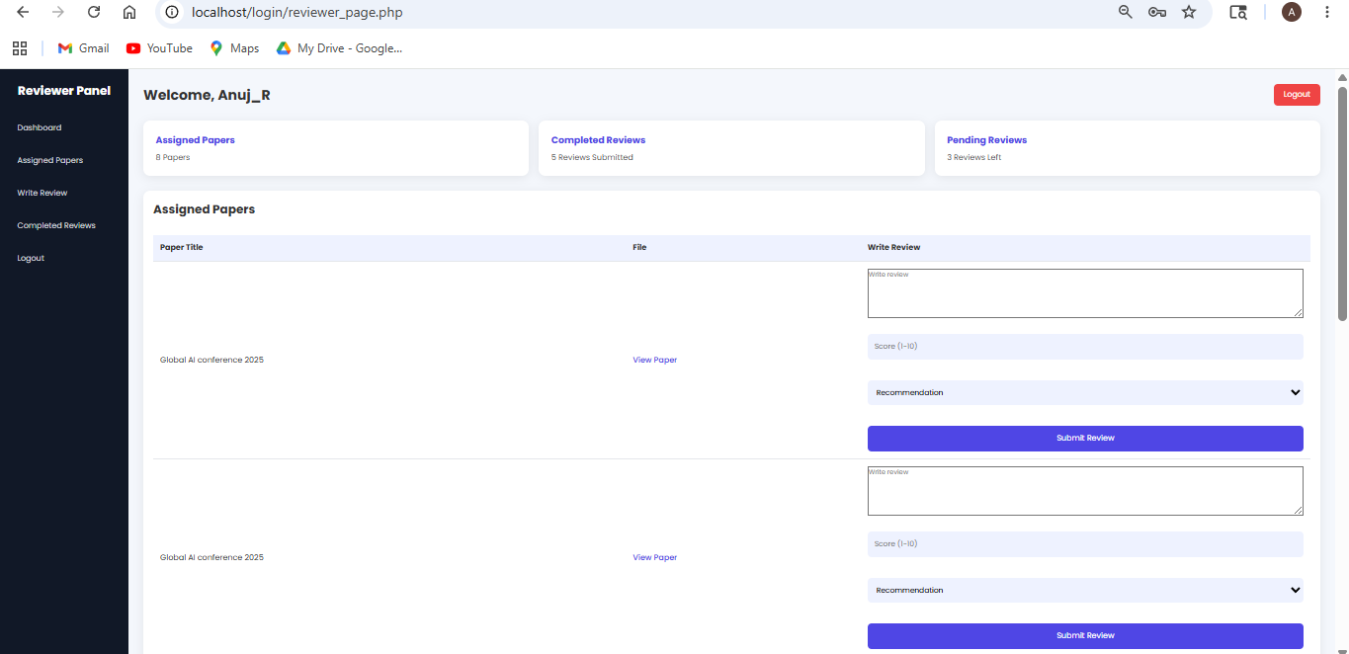

Admin Dashboard UI webpage
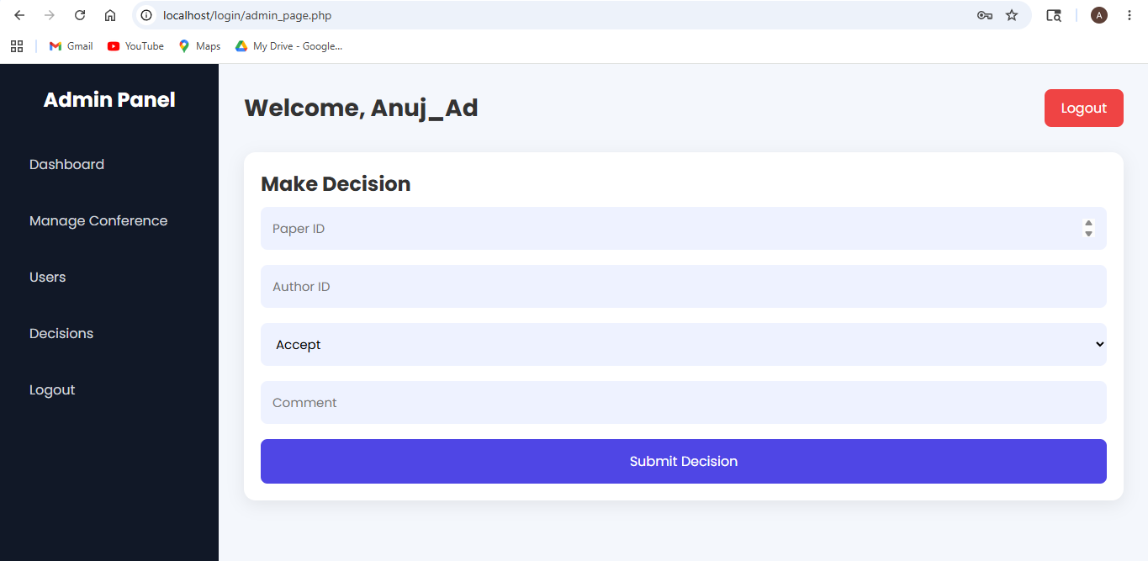

DATABASE ‘phpMyAdmin’ UI screens :
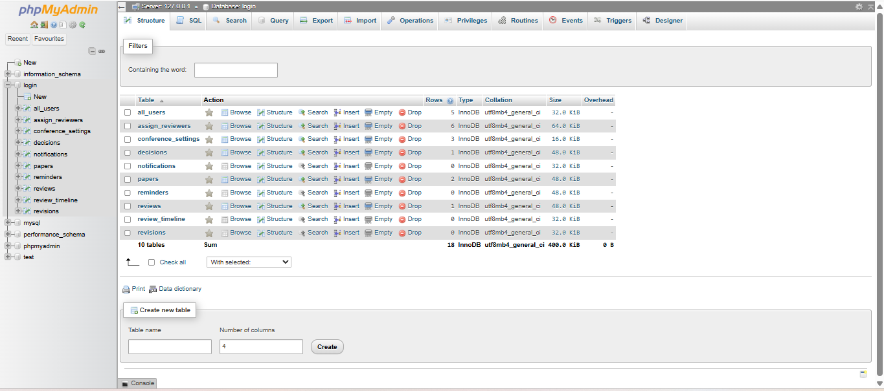
This is ‘login’ database having 10 tables (all_users, assign_reviewers, conference settings, decisions, notifications, papers, reminders, reviews, review_timeline, revisions).

all_users table
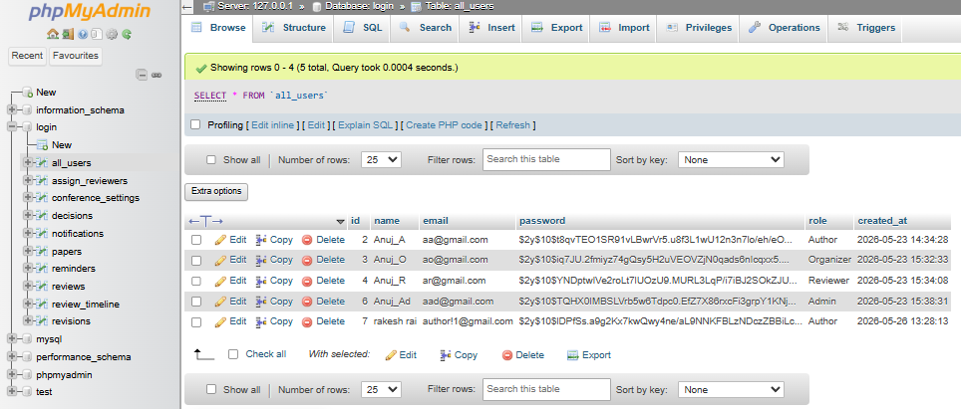

assign_reviewers table
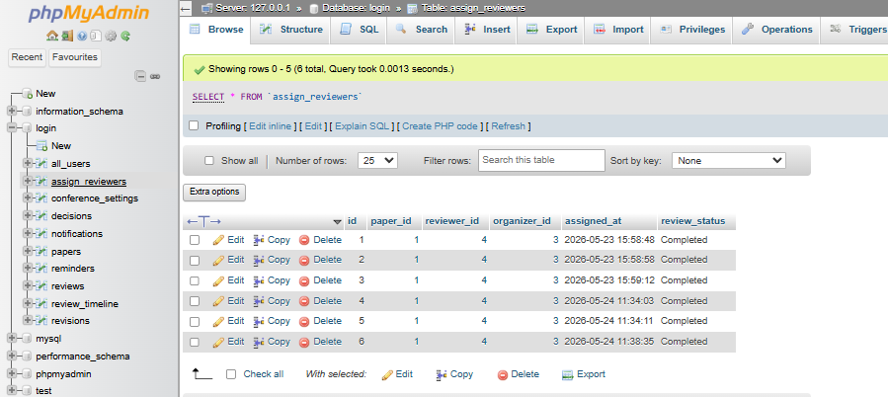

Conference_settings table
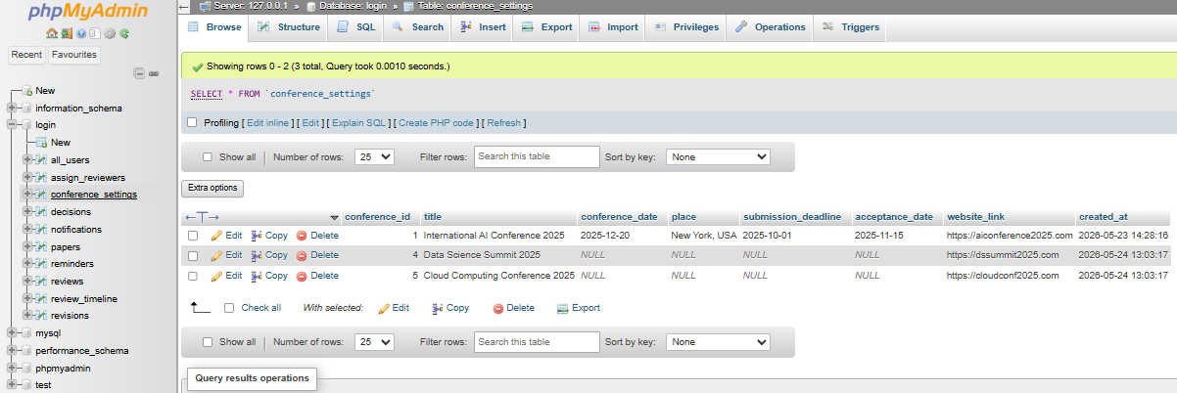

Decisions table
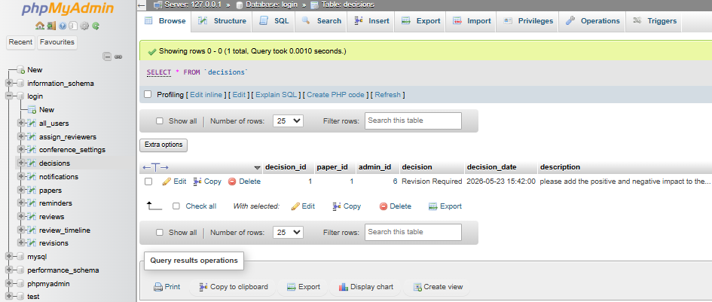

papers table
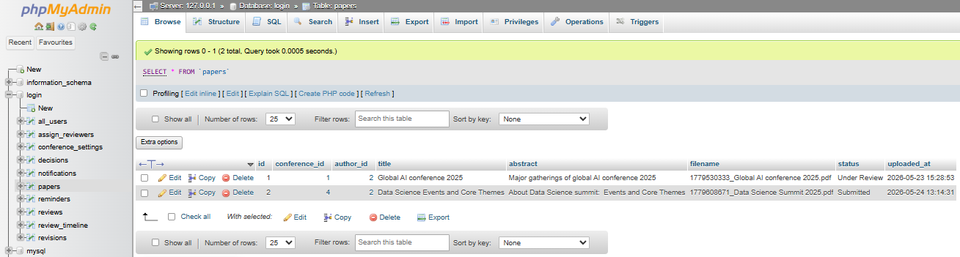

reviews table
